**Brite: Social Media Tool Kit**

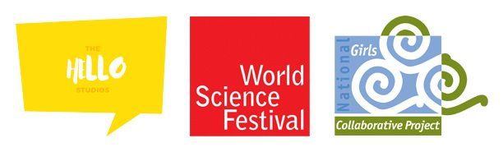

**Brite** is a bold, interdisciplinary program built especially for girls ages 13-16 beginning on July 13th, 2020. A combination of COVID-19, the summer slide, and lack of equity across the science field for females create an urgent need to fill the vacuum of programs, which cannot be held in person this year. In a first-of-its-kind collaboration, the [World Science Foundation](https://www.worldsciencefestival.com/) (WSF), National Girls Collaborative Project (NGCP), and [The Hello Studios](https://jenstancil.com/home/the-hello-studios) are joining forces to bring a high-quality STEM-centered program. 

**Brite** consists of three new courses that explore unique topics, such as the intersection of art and science, balancing the risks and rewards of new discoveries, and the mysteries of the mind. Each week world-class women scientists from cutting-edge fields blend their personal and professional stories to discuss their pioneering careers. Individual and collaborative activities anchor the speakers with a 1:1 device structure that allows for immersion in **Brite**, its online platform and learning tools. The courses are augmented with behind-the-scenes tours of museums, parks, labs and studios. Each week culminates with “**Brite**Fest” hosted by the girls themselves, sharing the projects they have been working on all week. **Brite** participants will receive certificates and digital badges upon completion.

***Social Media Handles***

**For all posts, please include the following hashtag(s):**

**#brite2020 or #girlsarebrite**

* **Facebook** 
  + WSF: <https://www.facebook.com/worldsciencefestival>
  + NGCP: <https://www.facebook.com/ngcproject>
  + Hello: <https://www.facebook.com/TheHelloStudiosbyJenStancil>
* **Twitter** 
  + WSF: <https://twitter.com/WorldSciFest>
  + NGCP: <https://twitter.com/ngcproject>
  + The Hello Studios: @jenstancil
* **Instagram** 
  + WSF: <https://www.instagram.com/worldscifest/>
  + NGCP: <https://www.instagram.com/ngcproject/>

***Logo & Picture Usage in Posts***

If possible, please share WSF, NGCP, and Hello Studios logos in social media posts, and on any newly created program materials.