

**Outreach and Messaging for NGCP Collaboratives**

**February 2019**

**Be sure to like, follow, and share!**

* Twitter: <https://twitter.com/the_connectory>
* Facebook: <https://www.facebook.com/connectory>
* Instagram: <https://www.instagram.com/theconnectory/>
* Join The Connectory mailing list: <http://ow.ly/veV530l9RKo>

|  |  |
| --- | --- |
| **Audience: Program Providers** | **Audience: Families/General Public** |
| **Newsletters/Email**  Have you added your STEAM activities for youth to [The Connectory](https://theconnectory.org/). Promote your K-12 camps, workshops, community events, and more to families and caregivers. It’s free and the [Getting Started Guide](https://theconnectory.org/need-help) makes it easy. Register and start connecting at [www.theconnectory.org](http://www.theconnectory.org). | **Newsletters/Email**  [The Connectory](http://www.theconnectory.org) is the largest and most comprehensive directory of science, technology, engineering, and math (STEM) providers and events. [The Connectory](http://www.theconnectory.org) was developed to promote local opportunities that build STEM and critical thinking skills essential for jobs in the 21st Century. Visit [www.theconnectory.org](http://www.theconnectory.org) today to find an exciting STEM opportunity near you. |
| **Twitter - @the_connectory**  Leap into Science is a national program that integrates open-ended science activities with children’s books for young children and their families. Search @the_connectory to find a #LeapintoScience event near you at theconnectory.org! #LeapWeek | **Twitter - @the_connectory**  Leap into Science is a national program that integrates open-ended science activities with children’s books for young children and their families. Search @the_connectory to find a #LeapintoScience event near you at www.theconnectory.org! #LeapWeek |
| **Facebook - @connectory**  **Instagram - @theconnectory**  Leap into Science is a national program that integrates open-ended science activities with children’s books for young children and their families. Search @the_connectory to find a #LeapintoScience event near you at theconnectory.org! #LeapWeek | **Facebook - @connectory**  **Instagram - @theconnectory**  Leap into Science is a national program that integrates open-ended science activities with children’s books for young children and their families. Search The Connectory to find a #LeapintoScience event near you at www.theconnectory.org! #LeapWeek |

**STEM vs. STEAM:** Feel free to substitute the acronym STEM for STEAM or use STEM/STEAM depending on your audience. Use hashtags whenever possible: #STEM #STEAM.

**Images:** Leap into Science Logo

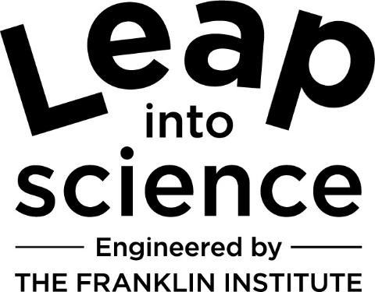

**The Connectory Logo:** The Connectory logo is available in several print and online formats for use by the Collaboratives and our partners. Download at: <https://theconnectory.org/style-guide-0>





**Website URL:** <https://theconnectory.org>

**Getting Started Guide**: <https://theconnectory.org/need-help>

**Refer questions to**: [info@theconnectory.org](mailto:info@theconnectory.org)