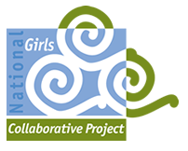**No Limits: Media Tool Kit** 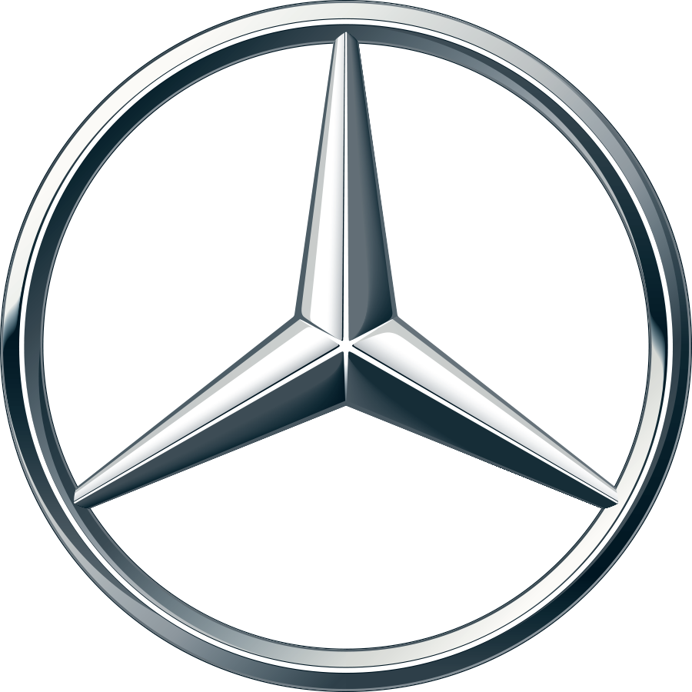

Mercedes-Benz USA and Mattel have teamed up to show children, particularly young girls, that they can aspire to be and do anything they desire. **There are no limits.**

Tackling the issue of gender stereotypes, Mercedes-Benz will give thousands of girls across the U.S. a die-cast Matchbox replica of the Mercedes-Benz 220SE commemorating Ewy Rosqvist’s historic Argentinian Grand Prix performance on November 4, 1962. Ewy Rosqvist rocketed across the finish line three hours ahead of the competition to win the unforgiving road race known for destroying cars because of treacherous terrain along its course.

Rosqvist and co-pilot Ursula Wirth drove the car to victory, making history on multiple counts. Setting a speed record of 126 km/h (78 mph), Rosqvist proved that women couldn’t just drive the Grand Prix — they could win it. **“They said I could never finish,” she says, “so I finished first.”**

***Social Media Handles and Hashtags***

**For all posts, please include the hashtags #girlshavenolimits**

* **Facebook**
  + Mercedes-Benz USA: <https://www.facebook.com/mercedesbenzusa/>
  + The National Girls Collaborative Project: [facebook.com/ngcproject](http://facebook.com/ngcproject)
  + Mattel: <https://www.facebook.com/Mattel/>
* **Twitter**
  + Mercedes-Benz USA: @MercedesBenzUSA / [twitter.com/mercedesbenzusa](https://twitter.com/mercedesbenzusa)
  + The National Girls Collaborative Project: @ngcproject / [twitter.com/ngcproject](http://twitter.com/ngcproject)
  + Mattel: @Mattel / [twitter.com/Mattel](https://twitter.com/Mattel)
* **Instagram**
  + Mercedes-Benz USA: @mercedesbenz / [instagram.com/mercedesbenz](https://www.instagram.com/mercedesbenz/)
  + The National Girls Collaborative Project: @ngcproject / [instagram.com/ngcproject](http://instagram.com/ngcproject)
  + Mattel: @Mattel / [instagram.com/mattel](https://www.instagram.com/mattel/)

***Logo & Picture Usage in Posts***

If possible, please share the Mercedes-Benz USA and National Girls Collaborative Project logos in social media posts, and on any newly created program materials . We will have a repository of photos to use available next week. Photos will be added throughout the course of the project. Each photo is provided in a rectangular and square crop, for use across social media platforms.

We encourage you to use your own photos as well. If you are using your own photos, please ensure that you have signed photo releases for the individuals in the photos.

***Press Release***

The press release for this project is here: <https://ngcproject.org/press>. You can use wording from this press release, link to it and create your own. Here is some sample text.

Mercedes-Benz USA and Mattel have teamed up to show children, particularly young girls, that they can aspire to be and do anything they desire. **There are no limits.** [Organization] has been selected as a participant of the [No Limits](https://www.youtube.com/watch?v=Boi6E8hhb4c&feature=youtu.be) project. Through partnership with [Partner Organizations], we are [short project description].

***Sample Social Media Posts***

|  |  |  |  |
| --- | --- | --- | --- |
|  | **Twitter** | **Facebook/LinkedIn/Google+** | **Instagram** |
| **Anytime** | We are excited to be a part of #XX with @MercedesBenzUSA, @Mattel, and @NGCProject. Together, we will show that girls can do anything with no limits. <https://bit.ly/2ld0tDK>  #girlshavenolimits | We are excited to support the No Limits project with @MercedesBenzUSA, @Mattel, and @NGCProject. Together we will disband stereotypes and show the world that girls can do anything with no limits. https://bit.ly/2ld0tDK | We are excited to be a part of #XX with @MercedesBenzUSA, @Mattel, and @NGCProject. Together we will disband stereotypes and show the world that girls can do anything with no limits. https://bit.ly/2ld0tDK |
| **To recruit participants in your community,**  ***If necessary*** | Join us and receive a free Ewy Rosqvist matchbox car. Together, we will show that girls can do anything with no limits. [event link]  #girlshavenolimits | Join us and receive a free Ewy Rosqvist matchbox car. In partnership with @MercedesBenzUSA, @Mattel, and @NGCProject, [Organization] is hosting [event] (link). Together we will disband stereotypes and show the world that girls can do anything with no limits. https://bit.ly/2ld0tDK | Join us and receive a free Ewy Rosqvist matchbox car. Together, we will show that girls can do anything with no limits. [event link] https://bit.ly/2ld0tDK |